Today, the silicon carbide (SiC) semiconductor is becoming the front runner in advanced power electronic devices. This material has been considered to be useful for abrasive powder, refractory bricks as well as ceramic varistors. Big changes have occurred owing to the author’s inspirational idea in 1968 to “make transistors from unusual material”. The current paper starts by describing the history of SiC research involving fundamental studies by the author’s group: unique epitaxial crystal growth techniques, the physical characterization of grown layers and processes for device fabrication. Trials for fabricating SiC power devices and their characteristics conducted until 2004 are precisely described. Recent progress in SiC crystal growth and peripheral techniques for SiC power devices are introduced. Finally, the present progress concerning SiC power devices is introduced together with the implementation of those devices in society.
Keywords: silicon carbide (SiC), step-controlled epitaxy, Schottky diode (SBD), metal-oxide-semiconductor field-effect transistor (MOSFET), power device, social implementation
Go to:

1. Introduction
Silicon carbide (SiC) was artificially synthesized at the end of the 19th century with the idea to create materials for abrasive powder and refractory bricks. Light emission was observed from a point-contact structure upon the application of a voltage at the beginning of the 20th century. After the invention of germanium (Ge) transistors, the realization of electronic devices operating at high temperatures was strongly desired, because Ge transistors did not work at above 60 ℃ owing to the narrow band gap (0.6 eV). In 1955, high-quality SiC single crystals were grown by a sublimation growth method (Lely method).¹⁾ This was before Si electronic devices appeared, and SiC high-temperature electronic devices came into the limelight. In U.S.A., a national project started, followed by studies in the Netherlands, England and Japan. However, it was very difficult to grow high-quality single crystals of SiC because of difficulty concerning polytype control. In the middle of 1950's, Si bipolar transistors were announced, and MOSFETs (metal-oxide-semiconductor field-effect transistors) were reported in 1960. Si electronic devices can operate even at 125 ℃, resulting in almost all research activities on SiC being stopped in the early 1970’s. Small efforts concerning SiC bulk crystal growth using a seeded sublimation method,²⁾ blue light-emitting diodes,³⁾ and bipolar transistors⁴⁾ were continued, which have partially contributed to the progress of today’s SiC power devices.
The author started research on SiC in 1968: the heteroepitaxial growth of SiC on Si wafers, because SiC substrates were not commercially available. It took more than 10 years to obtain the reproducible growth of 3C-SiC owing to the aid of a low-temperature grown buffer layer. Using a 3C-SiC hetero-epitaxially grown on Si, similar as that of the author’s group, an experimental 3C-SiC MOSFET device was reported in July 1986.⁵⁾ Although this device allowed normally-on field-effect operation, it did not show any saturation characteristics at high drain voltages. The author’s group demonstrated world-first normally-off behavior with saturation characteristics like those of 3C-SiC MOSFETs in December 1986.⁶⁾
However, the author was not satisfied by the device performance: a superimposed leakage current on the drain current at above a few volts of the drain voltage. This might have come from a large lattice mismatch of around 20% between SiC and Si. The author decided to use a small single crystalline part of SiC Acheson crystals used for blue light-emitting diodes. After taking a small single crystalline part from a bulk Acheson crystal, its backside (not flat) should be polished using a special jig to make a flat surface. During polishing, an off-angle was made unintentionally, and the author’s group grew an epitaxial layer on the polished surface using chemical vapor deposition. The author subsequently found an unexpectedly high-quality single crystal with the same polytype as that of the SiC substrate. After detailed experiments, the author named this process “step-controlled epitaxy”, which was a big breakthrough in the history of SiC device technology.⁷⁾ Their details are explained in Section 3. Stimulated by epoch-making technologies, the opportunity to use SiC for power electronic devices grew ripe in the early 1990’s. Research and development concerning SiC crystals and power electronic devices have been accelerated around the world.
In this paper, fundamental research conducted in the author’s group until 2004 is described. The details of “step-controlled epitaxy” are reviewed. The growth mechanism of SiC, growth modes, rate-determining processes, and surface morphology, are described. Optical and electrical characterizations of undoped SiC epitaxial layers are presented. Impurity doping during epitaxial growth and ion implantation are described for real semiconductor technologies. Recent progress of SiC power devices after 2004 is introduced along with various applications and implementations in society.
Go to:

2. History of SiC research
Silicon carbide is an IV–IV compound semiconductor that shows polytypism.⁸⁾ It is the phenomenon of taking different crystal structures in one-dimensional variation with the same chemical composition. Any change of the occupation sites along the c-axis gives different crystal structures, named ‘polytypes’. SiC is recognized to crystallize in more than 200 different polytypes. The polytypes are expressed by the number of stacking Si-C layers in a unit cell, and the crystal system (C, cubic; H, hexagonal; and R, rhombohedral). The atom arrangements of popular polytypes such as 3C-, 4H- and 6H-SiC are represented in Fig. ​Fig.1.1. Here, A, B, and C are the occupation sites in a hexagonal close-packed structure. Among many polytypes, technologically important ones include the above-mentioned 3 polytypes. In general, 3C-SiC is known to be a low-temperature stable polytype, which often appears at low temperatures. Whereas, 4H- and 6H-SiC are known as high-temperature stable polytypes, which need relatively high temperature to grow.

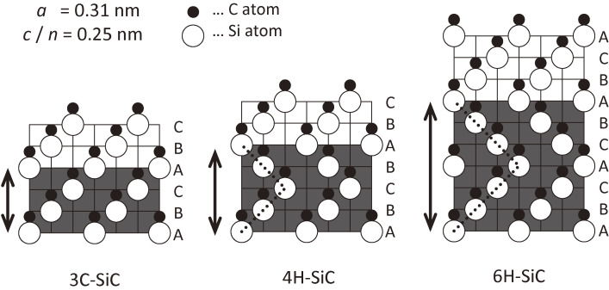
Figure 1.
Arrangements of Si and C atoms for 3C-, 4H-, and 6H-SiC. A, B, and C are occupation sites of hexagonal close-packed structures.
The typical properties of SiC are listed in Table ​Table11 together with those of GaN, Si and GaAs. The wide band gap of SiC gives the material a very high breakdown field strength, about ten-times higher than that of Si and GaAs. Tight Si-C bonding yields high-frequency lattice vibrations, namely high-energy optical phonons (100–120 meV), which lead to a high saturation drift velocity (2 × 10⁷ cm/s) and high thermal conductivity (4.9 W/Kcm).

Table 1.
Typical properties of SiC, GaN, Si and GaAs
 | SiC(4H) | GaN | Si | GaAs
Band gap (eV) | 3.26 | 3.39 | 1.12 | 1.43
Electron mobility (cm²/Vs) | 1,000 | 1,000 | 1,350 | 8,000
Breakdown field strength (MV/cm) | 3.0 | 3.0 | 0.3 | 0.4
Saturation drift velocity (cm/s) | 2 × 10⁷ | 2 × 10⁷ | 1 × 10⁷ | 1 × 10⁷
Thermal conductivity (W/Kcm) | 4.9 | 1.3 | 1.5 | 0.5
Open in a separate window
These excellent properties and the controllability of the p- and n-type by impurity doping make SiC a very attractive semiconductor. Selective doping of both donor and acceptor impurities can be achieved by ion implantation into SiC. Besides, SiC is the only one compound semiconductor that can be thermally oxidized to form high-quality SiO₂. These outstanding properties give great potentials for high-power, high-frequency, high-temperature, and radiation-resistant electronic devices. Particularly, theoretical simulations have predicted that SiC power electronic devices will overtake present-day Si power devices, mainly Si-IGBT (Insulated Gate Bipolar Transistor), on account of the extremely high efficiency, low power dissipation, reduced chip sizes, and possibility to use an easy cooling system.
Although the potentials of SiC have been recognized for a long time, difficulty in the growth of high-quality, large SiC crystals without polytype mixing had prevented electronic applications. It is very essential to control the polytypes during crystal growth in order to make SiC available for real applications. Nowadays, as for substrates, 4H-, and 6H-SiC wafers of 4-, and 6-inches in diameter grown by seeded sublimation techniques, are commercially available, and 8-inch wafers have been demonstrated.
For the epitaxial growth of SiC, chemical vapor deposition (CVD) has advantages regarding precise control and uniformity of the epitaxial layer thickness and impurity doping. There had been several trials of CVD in the early days, however a serious problem concerning polytype mixing existed. In the case of growth on 6H-SiC {0001} basal planes: a high temperature above 1,800 ℃ is required to obtain 6H-SiC; otherwise, 3C-SiC twin crystals are grown.^{9,10)} In the late 1980’s, the author’s group developed a new technique of “step-controlled epitaxy”, in which the homoepitaxial growth of 6H-SiC can be realized at a low temperature of 1,500 ℃ using off-axis 6H-SiC {0001}.⁷⁾ In “step-controlled epitaxy”, surface steps were formed by employing an off-axis substrate to grow an epitaxial layer which has the same polytype as that of the substrate. This technique was epoch-making for two reasons: (i) the growth temperature can be reduced by more than 300 ℃, and (ii) epitaxial layers have sufficiently high quality for device applications. Other groups^{11–17)} followed the homoepitaxial growth on off-axis SiC {0001} substrates. Rapid progress in SiC device fabrication has been supported by “step-controlled epitaxy”, which is a key technology for the research and development of present-day SiC power electronic devices.
Go to:

3. “Step-controlled epitaxy” of SiC

3.1. Growth by chemical vapor deposition (CVD).
Fundamental studies on epitaxial growth were carried out using atmospheric-pressure CVD with a cold-wall horizontal reactor made of fused quartz in the author’s group.^{18,19)} Silane (SiH₄: 1% dilution by H₂) and propane (C₃H₈: 1% dilution by H₂) were used as source gases, and purified hydrogen (H₂) gas with a silver-palladium (Ag-Pd) cell was used as the carrier gas. The flow rates of SiH₄ and C₃H₈ were typically 0.30 sccm and 0.20 sccm, respectively. The H₂ flow rate was fixed at 3.0 slm, which provided a linear gas velocity of 6–10 cm/s above SiC substrates. Substrates were heated on a SiC-coated graphite susceptor using radio-frequency (rf) induction. Before CVD growth, in situ hydrochloric (HCl) gas etching was carried out at 1,300 ℃ for 10 min to remove any surface damage introduced by polishing processes. The growth temperature was varied over the range of 1,100–1,600 ℃ (typically 1,500 ℃).
In the early stages of research in the author’s group, two kinds of substrates, crystals grown by an Acheson method and a seeded sublimation method, were used. Acheson crystals have naturally grown {0001} basal planes, and an off-angle was introduced by angle lapping. As for seeded sublimation grown crystals, both commercial and homemade wafers were used. The polytype of substrates was identified by their absorption edges in ultraviolet to visible-light transmission spectra and photoluminescence, which was confirmed by X-ray diffraction and Raman scattering. The off-angle was 0–10° along 〈112¯0〉. Both (0001)-Si and (0001¯)-C faces were used to investigate the effects of the substrate polarity on epitaxial growth. The surface polarity of the substrate was determined using any differences in the oxidation rates: (0001¯)-C faces have faster oxidation rates than (0001)-Si faces.^{20,21)}

3.2. “Step-controlled epitaxy”.
Figure ​Figure22 shows a comparison of typical layers grown on the off-axis (6° off along 〈112¯0〉) and on-axis (just) 6H-SiC (0001)-Si faces obtained by the author’s group.^{18,19)} The surface morphology was characterized by a Nomarski microscope, the crystal structure by reflection high-energy electron diffraction (RHEED) (〈112¯0〉 azimuth), and the etched surface morphology by a scanning electron microscope after molten KOH etching. These layers were grown at 1,500 ℃ under a typical gas flow condition with a growth rate of 2 µm/h; their thickness was about 5 µm.

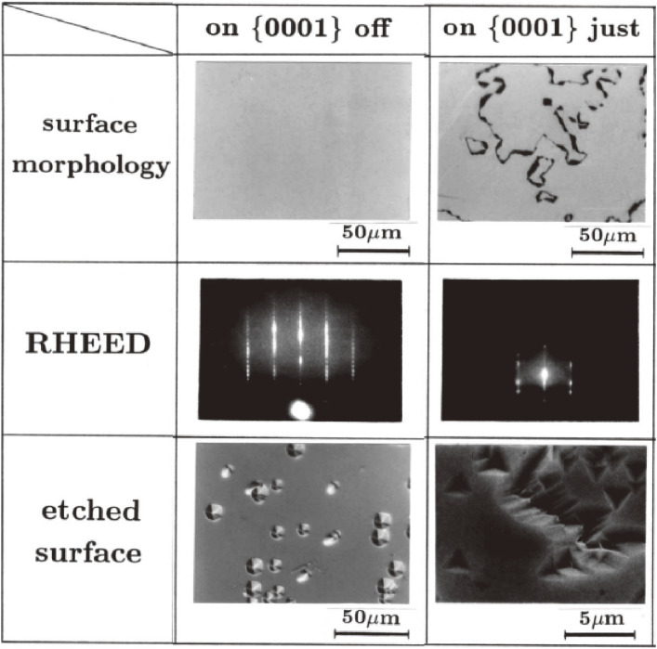
Figure 2.
Comparison of epitaxial layers grown on the off-axis (6° off) and on-axis (just) 6H-SiC (0001)-Si face. Surface morphology, RHEED pattern, and etched surface.
The layers grown on the off-axis (0001)-Si face exhibited a specular smooth surface, and the RHEED pattern showed the growth of single crystalline 6H-SiC. The round-shaped hexagonal etch pits show 6-fold symmetry. Thus, the polytype of the grown layers was identified as 6H-SiC. The polytype of the grown layers was also confirmed using a transmission electron microscope (TEM). Here, by using off-axis 6H-SiC (0001) substrates, homoepitaxial layers with excellent surface morphology could be obtained at a low temperature of 1,500 ℃. Homoepitaxial layers with a specular surface were also reproducibly grown on the off-axis (0001¯)-C faces.
The layer grown on the on-axis (0001)-Si face has a smooth surface with a mosaic pattern showing several domains separated by groove-like boundaries. The RHEED pattern of the grown layer indicates 3C-SiC (111) with twinning. The triangular shape of etch pits with 3-fold symmetry suggests growth of the cubic phase. The etch pits are rotated by 180° relative to each other in neighboring regions across grooves, indicating double positioning twins.²²⁾ The layers grown on on-axis (0001¯)-C faces show a bumpy surface caused by island growth (not shown),¹⁹⁾ and its RHEED pattern also shows twin crystalline 3C-SiC.
Epitaxial growth on 6H-SiC (0001)-Si faces with different off-directions were studied.^{7,23)} On a 6H-SiC (0001)-Si face with a small off-angle of less than 1.5°, inclined along 〈11¯00〉, a stripe-like morphology appeared (not shown here), which was probably caused by pronounced step bunching, and the inclusion of 3C-SiC domains was observed after long-time growth. Thereafter, epitaxial growth on off-axis (0001)-Si faces inclined along 〈112¯0〉 was mainly studied for a long time. Even on the off-axis along 〈11¯00〉, a similar growth mode as on the off-axis along 〈112¯0〉 was obtained, when a large off-angle of 8° was chosen.²⁴⁾
The growth mode on the off-axis (0001)-Si face is explained using the schematic illustration shown in Fig. ​Fig.3(a).3(a). Here, A, B, and C denote the occupation sites of Si-C pairs in the hexagonal close-packed structure. In CVD, adsorbed chemical species (normally Si-related species) migrate on the surface and are incorporated into a crystal at the steps where the surface energy is low. As shown in Fig. ​Fig.3(b),3(b), on off-axis substrates the growth occurs in a step-flow manner, whereas on on-axis substrates the two-dimensional mode is mainly faster.

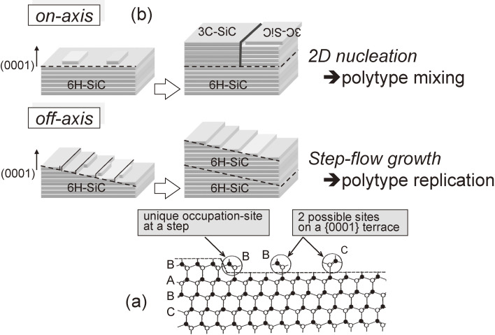
Figure 3.
Explanation of “step-controlled epitaxy”. (a) Incorporation sites on the 6H-SiC (0001)-Si face (terrace or step). White and black circles denote Si and C atoms, respectively. A, B, and C are occupation sites of hexagonal close-packed structures. (b) Growth modes and polytypes on 6H-SiC substrates: on off-axis homoepitaxy of 6H-SiC by step-flow growth; on on-axis twin structure 3C-SiC by two-dimensional nucleation.
We accidentally found the above difference. Normally, Acheson crystals have small single-crystalline parts that show a natural-flat surface. For using small crystals, their back side should be polished in order to put on a SiC-coated wafer susceptor. An off-axis substrate was made accidentally during polishing. CVD growth occurred on the off-axis substrate, and got this difference during epitaxial growth. During that term, the author did not know about ‘step-flow growth’ and tried to understand the growth mechanism.
On off-axis {0001} faces, the surface has a high density of steps, and the terrace width becomes narrow enough for Si-related adsorbed chemical species to reach steps, even at 1,500 ℃. At steps of the substrate, the incorporation site is uniquely determined by chemical bonds from the side of steps and those of the substrate. Therefore, the same stacking sequence as that of the substrate can be replicated through ‘step-flow growth’: successful homoepitaxial growth of the same polytype at 1,500 ℃, almost 300 ℃ lower than ever reported.
On on-axis (0001)-Si faces, however, wide terraces exist on the substrate surface with a very low step density. The adsorbed chemical species cannot have a sufficient migration length to reach steps at 1,500 ℃, because the terrace width is rather wide. Therefore, crystal growth occurs mainly on terraces through two-dimensional nucleation. Thus, low-temperature stable 3C-SiC crystals grow on the on-axis {0001} faces. Because the stacking sequence of 6H-SiC is ABCACB…, the grown 3C-SiC takes two possible stacking sequences of ABCABC… or ACBACB…, which gives the twinning relation shown in Fig. ​Fig.33(b).
Studies about epitaxial growth on off-axis substrates had been extensively carried out for various materials. Although the use of off-axis substrates has been known to use ‘step-flow growth’, this technique for SiC possesses a special meaning: that high-temperature stable polytypes can be grown at rather low temperatures using the ‘step-flow growth’ mode, while preventing polytype mixing. The surface steps serve as a template that enforces replication of the complicated stacking sequence of the substrate polytype. This is the reason why the author named it as “step-controlled epitaxy”.

3.3. Growth characteristics of “step-controlled epitaxy”.

3.3.1. Off-angle dependence of the growth rate.
The growth rates of epitaxial layers at 1,500 ℃ on 6H-SiC {0001} substrates for various off-angles are shown in Fig. ​Fig.44.²⁵⁾ The flow rates of SiH₄ and C₃H₈ were 0.30 sccm and 0.20 sccm, respectively. The open triangles (on a (0001)-Si face) and closed ones (on a (0001¯)-C face) indicate the growth of 3C-SiC. On on-axis substrates, higher growth rates were obtained on (0001¯)-C faces, which is ascribed to the higher nucleation rate on (0001¯)-C faces.^{18,19)} The open and closed circles indicate the growth of 6H-SiC (homoepitaxy). Although the homoepitaxial growth of 6H-SiC can be realized on off-axis substrates with more than a 1° off-angle, the growth rates are high for off-angles of below 3.5°, due to the mixing of two-dimensional nucleation on terraces. With increasing off-angle, the growth rates on both faces become almost the same value (in this case, 2.5 µm/h) for off-angles from 4 to 10°.

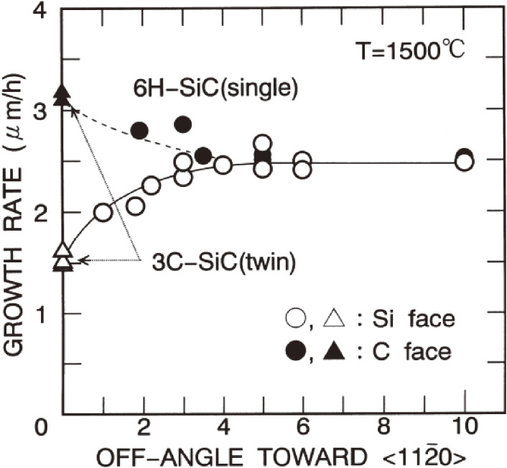
Figure 4.
Dependence of the growth rate on the off-angle at 1,500 ℃. Open and closed triangles, growth of 3C-SiC; circles, growth of 6H-SiC. The flow rates are: SiH₄ (0.30 sccm); C₃H₈ (0.20 sccm).

3.3.2. Rate-determining process.
The growth rate depends on the C/Si ratio, as shown in Fig. ​Fig.55.²⁵⁾ The growth was done at 1,200 ℃ and 1,500 ℃ on 6H-SiC (0001¯)-C faces with an off-angle of 6° along 〈112¯0〉. The flow rate of C₃H₈ was varied over the range of 0.10–0.40 sccm by keeping the SiH₄ flow rate at fixed values. The closed and open circles are the growth rates at 1,500 ℃ when the SiH₄ flow rates were 0.15 sccm and 0.30 sccm, respectively. In the region of C/Si > 1.4, the growth rate has an almost constant value, and it increases proportionally with the flow rate of SiH₄, indicating the rate was determined by the supply of SiH₄. In the region of C/Si < 1.4, the growth rate decreases remarkably with decreasing C/Si due to the lack of C sources. At 1,200 ℃, the growth rate starts to increase linearly and shows saturation at a higher C/Si ratio, as shown by the open triangles, due to the insufficient decomposition of C₃H₈.

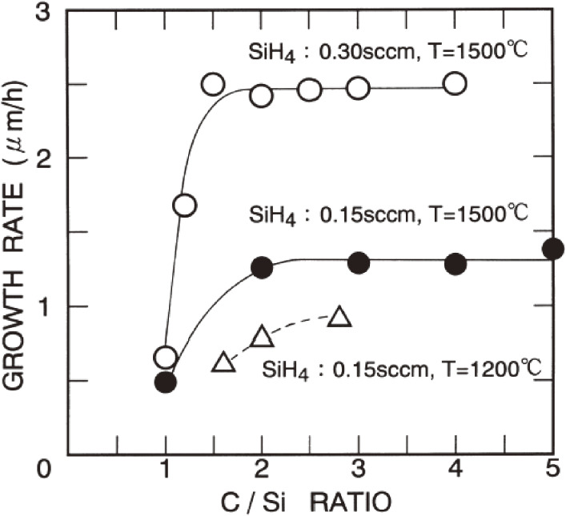
Figure 5.
Dependence of the growth rate on the C/Si ratio. Closed and open circles are for growth at 1,500 ℃, and triangles at 1,200 ℃. Substrates: 6° off-axis 6H-SiC (0001¯)-C face. Flow rate: C₃H₈ (0.10–0.40 sccm); SiH₄ (fixed).
Through studies on gas-phase and surface reactions at 1,200–1,600 ℃ in a SiH₄-C₃H₈-H₂ system²⁶⁾ and gas-phase kinetics,²⁷⁾ the dominant chemical species contributing to SiC growth were revealed to be Si, SiH₂, Si₂H₂ from SiH₄, and CH₄, C₂H₂, C₂H₄ from C₃H₈. In the growth of SiC, Si (or SiH₂) may be preferentially adsorbed and migrate on the surface and make chemical bonds with SiC substrates; then, C-related chemical species in neighboring atmosphere corporate into the attached Si. In fact, no deposition occurs without SiH₄ supply.

3.3.3. Temperature dependence of growth rate.
In Fig. ​Fig.6,6, the temperature dependence of the growth rate is shown in the range of 1,200–1,600 ℃, in which the homoepitaxial growth of 6H-SiC can be realized.²⁵⁾ The flow rates of SiH₄ and C₃H₈ were 0.15 sccm and 0.10–0.14 sccm, respectively, and the off-angle of the substrates was 5–6°. The growth rates on the (0001)-Si and (0001¯)-C faces show almost the same value in the measured temperature range. The data gives an Arrhenius-type curve with an activation energy of 2.8 kcal/mole. To explain the temperature dependence, a stagnant-layer model²⁸⁾ was applied to the present system with some modification, because the growth rate of SiC is determined by the supply of Si species, as shown in the figure. The model was originally developed for Si epitaxial growth to improve the thickness uniformity based on experiments of gas-flow patterns. In this model, the growth is assumed to be governed by the diffusion of chemical species in the stagnant layer from the main gas stream to a substrate surface. By giving the diffusion constant of SiH₄ in H₂, the partial pressure of SiH₄, the mean gas velocity, the substrate temperature, the free height of the reactor, the spacing of the 6H-SiC {0001} face, the density of the surface adsorption sites, the gas density, gas viscosity, and the stagnant layer thickness, the growth rate at a certain position on the substrate can be calculated.²⁵⁾

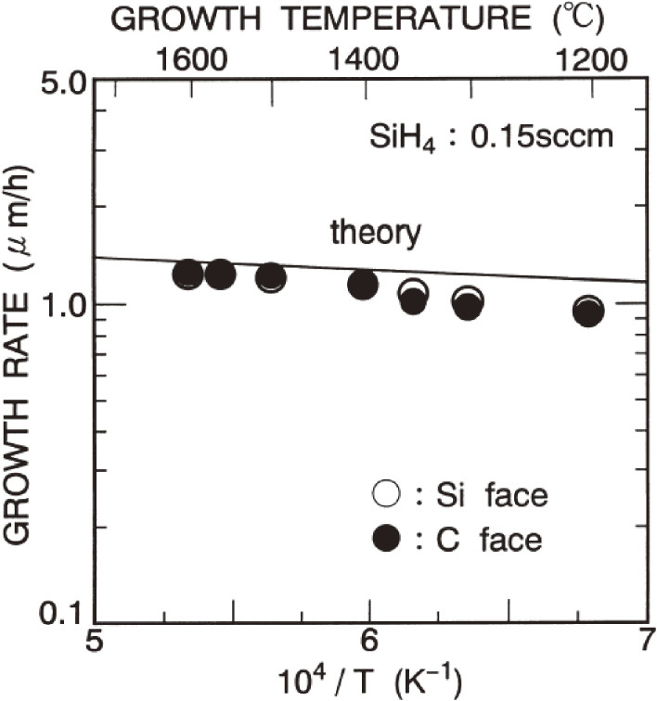
Figure 6.
Temperature dependence of the growth rate on 5–6° off-axis 6H-SiC (0001)-Si and (0001¯)-C faces. The solid curve shows the calculated results based on a stagnant-layer model. Flow rates: SiH₄ (0.15 sccm); C₃H₈ (0.10–0.14 sccm).
The calculated temperature dependence of the growth rate is shown by the solid curve in Fig. ​Fig.66.²⁵⁾ The absolute value obtained by the simple model shows surprisingly good agreement with the experimental data. The growth rate gradually increases with increasing temperature due to enhanced diffusion in the stagnant layer at high temperatures. The curve in the range of 1,200–1,600 ℃ is of an Arrhenius type with a slope of 2.4 kcal/mole, which is in very good agreement with the experimental results. Thus, the SiC growth in “step-controlled epitaxy” is probably limited by the mass transport. This explains why there is little difference in the growth rates on the off-axis (0001)-Si and (0001¯)-C faces, because no surface polarity effect appears in growth controlled by mass transport.²⁵⁾

3.4. Surface structures and growth mechanism.
Epitaxial layers grown on (0001)-Si faces at 1,500 ℃ exhibited specular smooth surfaces, as shown in Fig. ​Fig.77,²⁹⁾ for C/Si ratios of between 2 and 6. However, on (0001¯)-C faces, the range of the optimum C/Si ratio for specular smooth surfaces was relatively narrow, from 2 to 3. The surface structures are very sensitive to substrate defects and polishing damage. Triangular pits and macrosteps are easily formed at defects, and often 3C-SiC nucleation occurs on most triangular pits.³⁰⁾

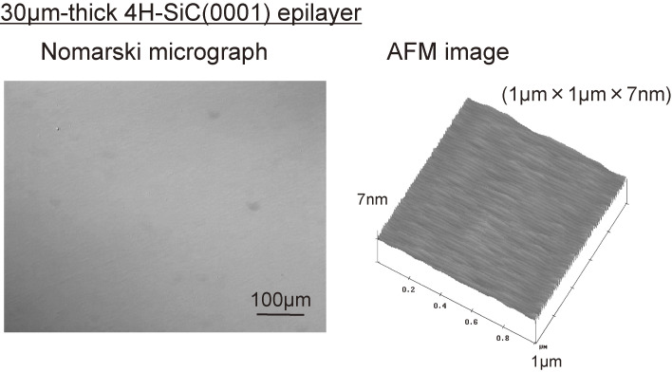
Figure 7.
Surface morphology observed by a Nomarski microscope and an AFM image of high-quality 30-µm thick 4H-SiC epitaxial layers with 8° off-angles (hot-wall reactor). On the (0001) Si-face, specular surfaces for a C/Si ratio of 2–6. Details of the surface are explained in the text.
In atomic force microscope (AFM) observations, a distinctive difference in the surface structures was observed on the (0001)-Si and (0001¯)-C faces.³¹⁾ On 6H-SiC (0001)-Si faces with an off-angle of 5°, apparent macrosteps were observed with a terrace width of 220–280 nm and a step height of 3–6 nm. On (0001¯)-C faces, however, the surface was rather flat and no macrosteps were observed. On 4H-SiC (0001)-Si faces macrosteps were observed with 110–160 nm width and 10–15 nm height in some regions. On 4H-SiC (0001¯)-C faces, a similar tendency as in 6H-SiC was observed. Based on cross-sectional transmission electron microscope (XTEM) observations for more than 200 steps in 6H- and 4H-SiC epitaxial layers on (0001)-Si and (0001¯)-C faces with an off-angle of 3.5°, histograms of the step height were made.³²⁾ On 6H-SiC, 88% of the steps were composed of 3 Si-C bilayers (half of the unit cell), and 7% of 6 Si-C bilayers (unit cell). However, on 4H-SiC, 4-bilayers (unit cell) were the most dominant (66%), and 2-bilayers had the second highest probability (19%).
After the success of “step-controlled epitaxy” using a cold-wall reactor, horizontal low-pressure hot-wall reactors were proposed for the growth of thick layers at around 1,600 ℃ in reasonable times.^{15,33,34)} A vertical low-pressure hot-wall reactor, named a chimney reactor, has also been proposed for thick epitaxial growth.^{35,36)} In the cold-wall reactor, a SiC-coated graphite susceptor easily sublimes owing to the large temperature difference between the susceptor and the cold wall, which impedes long-time growth. Thus, the thickness of the epitaxial layer has been limited to below 10 µm with a growth rate of around 2.5 µm/h. By using hot-wall reactors, mirror-like SiC epitaxial layers were obtained with growth rates of 10–30 µm/h in the temperature range of 1,750–1,900 ℃. The surface morphology and physical properties were not very different for epitaxial layers grown either by a cold-wall reactor or a hot-wall reactor.
Experimentally, a higher growth rate is achieved at lower pressures: A reduced residence time in the gas phase and minimization of the gas-phase nucleation may be a reasonable explanation.²⁹⁾ The increased diffusion rate to the surface at lower pressure is an important factor. Also, the boundary layer is diminished at lower pressure, so that the diffusion distance becomes shorter. At lower pressure, a higher surface mobility of adsorbed species may be expected, which would lead to a higher growth rate.
Go to:

4. Characterization of epitaxial layers

4.1. Surface morphology.
The surface morphology of epitaxial layers grown under the optimized conditions showed a quite specular smooth surface. A layer of 30 µm was grown by a hot-wall reactor on 4H-SiC (0001) with an 8° off-angle. No macrosteps were observed by a Nomarski microscope, and the full width at half maximum of the X-ray rocking curve was 9.0 arcsec, which is quite close to the resolution limit of the analytical system. The root-mean-square surface roughness was 0.2 nm, as shown in the AFM image in Fig. ​Fig.77.²⁹⁾ Defects on the surface examined by a Nomarski microscope after etching with molten KOH at 480 ℃ for 5 min are shown in Fig. ​Fig.88.²⁹⁾ Large hexagonal pits correspond to micropipes (open-core screw dislocations), and small hexagonal pits originate from screw dislocations.³⁷⁾ “Shell-shaped” pits have been revealed to originate from dislocations in the basal plane.³⁸⁾

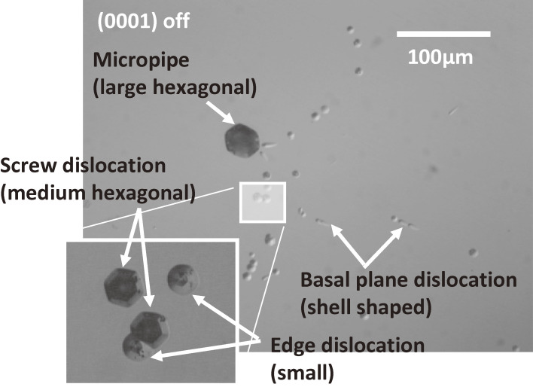
Figure 8.
Surface morphology observed by a Nomarski microscope for an etched surface of 4H-SiC after molten KOH etching. Large hexagonal pits, micropipes (open-core screw dislocations); small hexagonal pits, screw dislocations; “shell-shaped” pits, dislocations in the basal plane.

4.2. Optical characterization.
The quality of epitaxial layers is normally characterized by photoluminescence. In Fig. ​Fig.9,9, a typical photoluminescence spectrum measured at 4.2 K using a He-Cd laser (325 nm) for a 75 µm 4H-SiC epitaxial layer is shown in the wide range and the band edge region in the inset.²⁹⁾ We grew an epitaxial layer by hot-wall CVD for unintentionally doped n-type with a donor concentration of 5 × 10¹² cm⁻³. Peaks of P₀ (3.256 eV) and Q₀ (3.244 eV) were found to be zero-phonon emission lines of excitons bound to neutral nitrogen substituting hexagonal and cubic sites.³⁹⁾ The mark “I” indicates the emission lines of free excitons with associated phonons, given by the subscripts (TA, transverse acoustic; LA, longitudinal acoustic; LO, longitudinal optic; TO, transverse optic). As in the figure, the band edge emission is dominant, and the donor (N, nitrogen)-acceptor (Al, aluminum) pair luminescence band³⁹⁾ (around 2.80–3.05 eV) is negligibly small, though the pair luminescence is dominant in substrates. The existence of definite free exciton peaks indicates a high-quality, high-purity epitaxial layer. The lack of zero-phonon lines for free exciton peaks reflects the indirect band structure of SiC.

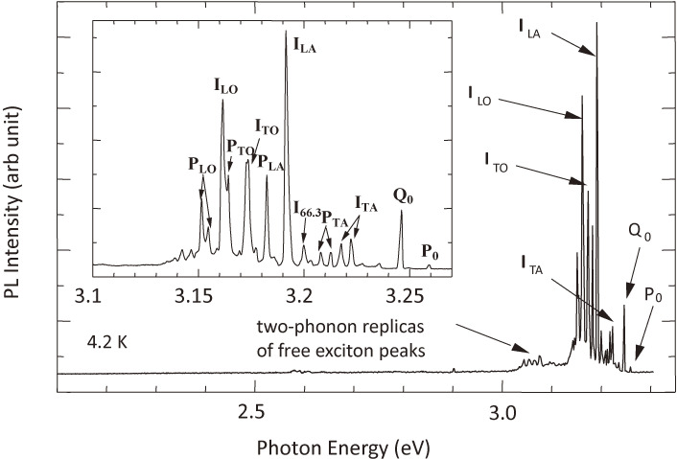
Figure 9.
Photoluminescence spectrum of 75-µm thick 4H-SiC at 4.2 K (hot-wall reactor). Unintentionally doped n-type of 5 × 10¹² cm⁻³. Peaks P₀ and Q₀: zero-phonon emission of excitons bound to neutral nitrogen substituting hexagonal and cubic sites. Peaks “I”: emission lines of free excitons with associated phonons, given by the subscripts (TA, transverse acoustic; LA, longitudinal acoustic; LO, longitudinal optic; TO, transverse optic).

4.3. Electrical characterization.
The electrical properties were characterized using Hall-effect measurements for undoped epitaxial layers (∼2.5 × 10¹⁶ cm⁻³) grown by atmospheric-pressure cold-wall CVD on p-type substrates.^{18,19)} Ohmic contacts were made by evaporated Ni annealed at 1,100 ℃ in Ar. Detailed analysis was done by curve fitting using an electrical neutrality equation⁴⁰⁾ for the temperature dependence of the carrier concentration in 10 µm 6H- and 4H-SiC epitaxial layers. A two-donor model was adopted, in which dopant impurities substitute at two inequivalent (hexagonal and cubic) sites with different energy levels (hexagonal and cubic N donors): 97 meV and 141 meV for 6H-SiC; and 71 meV and 124 meV for 4H-SiC.^{39,41)} The acceptor concentration was determined through this curve fitting, which gives a very low compensation ratio of 2 × 10⁻³. The electron mobility at room temperature was 351 cm²/Vs for 6H-SiC and 724 cm²/Vs for 4H-SiC.
In Fig. ​Fig.10,10, the temperature dependence of electron mobility for 4H-SiC is shown.²⁹⁾ The sample is intentionally doped n-type with a thickness of 20 µm, grown by hot-wall CVD on semi-insulating 4H-SiC. A donor concentration of 5 × 10¹⁴ cm⁻³ was obtained by curve fitting with an acceptor concentration of 1 × 10¹³ cm⁻³. The electron mobility is 981 cm²/Vs at 293 K and goes up to 46,200 cm²/Vs at 42 K. In the low-temperature region below 130 K, the temperature dependence shows acoustic phonon scattering, and in the high temperature above 130 K, it shows optical phonon scattering.

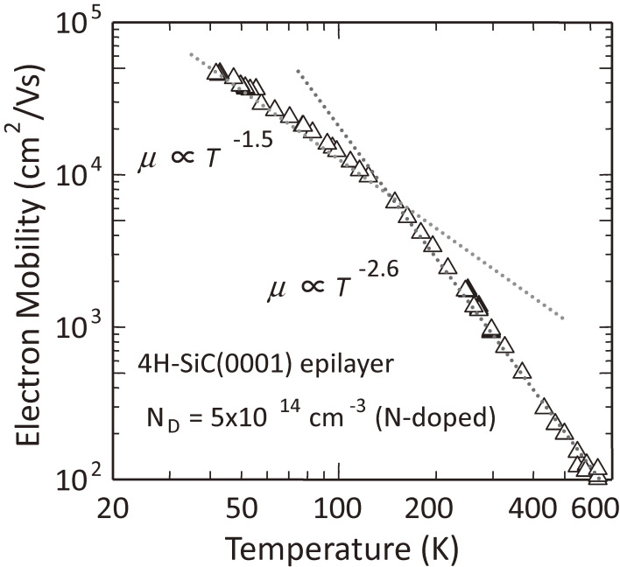
Figure 10.
Temperature dependence of the electron mobility for intentionally doped n-type 20 µm thick 4H-SiC (hot-wall reactor). Donor concentration, 5 × 10¹⁴ cm⁻³; acceptor concentration, 1 × 10¹³ cm⁻³. Electron mobility: 981 cm²/Vs (293 K), 46,200 cm²/Vs (42 K). Below 130 K, acoustic phonon scattering; above 130 K, optical phonon scattering.
Go to:

5. Fabrication processes for SiC devices

5.1. Impurity doping.
Figure ​Figure1111 shows the background donor concentration vs. the C/Si ratio of source gases for unintentionally doped epitaxial layers grown by atmospheric-pressure cold-wall CVD.^{18,19)} The donor concentration was determined by the capacitance-voltage (C-V) characteristics. For a C/Si ratio of 2, no significant difference was observed for the epitaxial layers on (0001)-Si and (0001¯)-C faces. The incorporation of nitrogen (N), the main donor impurity in SiC, strongly depends on the C/Si ratio during CVD growth (site-competition epitaxy).⁴²⁾ High C/Si ratios lead to lower donor concentrations: high coverage by C atoms on the growing surface prevents the incorporation of N atoms into C sites of epitaxial layers. By increasing the C/Si ratio, the background doping level is remarkably reduced on the (0001)-Si face, as shown in the figure. The lowest value was in the range of 5 × 10¹³–2 × 10¹⁴ cm⁻³. On the (0001¯)-C face, however, the background doping concentration is not sensitive to the C/Si ratio.

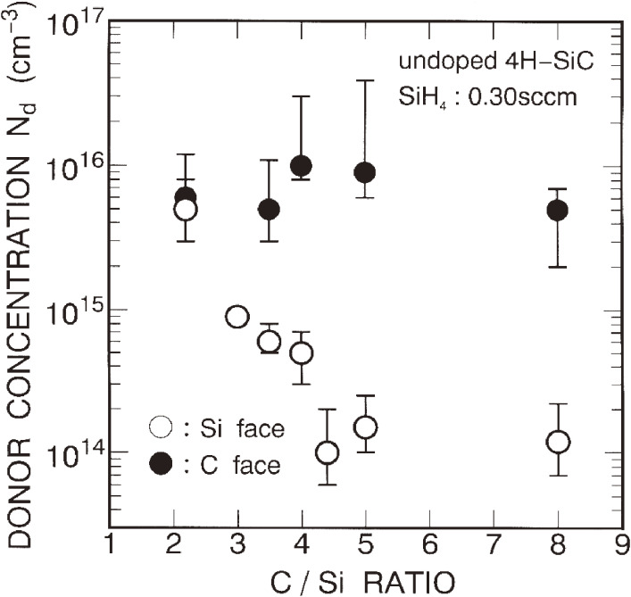
Figure 11.
C/Si ratio dependence of the background donor concentration at room temperature for undoped 4H-SiC epitaxial layers. For a low C/Si ratio of 2, no significant difference; for increasing the C/Si ratio, the donor concentration is remarkably reduced on the (0001)-Si face; the lowest value is in the range of 5 × 10¹³–2 × 10¹⁴ cm⁻³.
N-type doping could be easily achieved by adding of N₂ gas during CVD growth.^{18,19)} The donor concentration increases in proportion to the N₂ flow rate in the wide range on both (0001)-Si and (0001¯)-C faces of 6H-SiC.⁴³⁾ Figure ​Figure1212 shows the electron mobility vs. the electron concentration at room temperature for 6H- and 4H-SiC epitaxial layers grown by atmospheric-pressure cold-wall CVD.^{18,19)} Although the electron mobilities of 4H-SiC exhibit larger values than those of 6H-SiC for lightly doped layers, the difference becomes small for heavily doped layers, as reported in a previous study.⁴⁴⁾ For device applications, 4H-SiC is more attractive owing to its higher electron mobility and smaller anisotropy.^{44,45)}

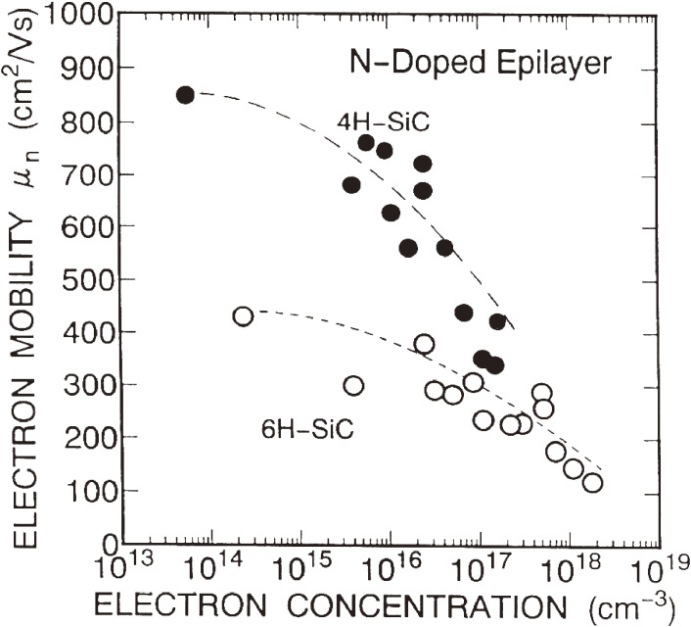
Figure 12.
Electron mobilities vs. electron concentrations at room temperature for N-doped 6H- and 4H-SiC grown by atmospheric cold-wall CVD. The electron mobilities of 4H-SiC are larger than 6H-SiC for lightly doped layers. The difference becomes small for heavily doped layers.
For p-type doping, trimethylaluminum (TMA: Al (CH₃)₃) was used. Al atoms work as acceptors by substituting at Si sites. Most of the Al-doped epitaxial layers showed very smooth surfaces; however, pits and hillocks were observed in heavily doped layers (Al concentration > 10¹⁹ cm⁻³) grown on (0001¯)-C faces. A high supply of TMA causes a shift of the growth conditions toward C-rich due to decomposition of the CH₃ fraction of TMA. The surface migration of chemical species is suppressed, which enhances nucleation on the terraces, and causes surface roughening. The Al acceptor concentration increases with the flow rate of TMA.^{18,19)} The doping efficiency of Al is much higher on (0001)-Si faces than that on (0001¯)-C faces by a factor of 10–80. On (0001)-Si faces, the acceptor concentration increases superlinearly with the TMA supply, which is caused by the increased effective C/Si ratio under high TMA flow rates. A very high hole concentration of 4–6 × 10¹⁹ cm⁻³ was achieved in heavily Al-doped epitaxial layers (Al concentration of in the mid 10²⁰ cm⁻³). The lowest p-type resistivity was 0.042 Ωcm for 6H-SiC and 0.025 Ωcm for 4H-SiC on (0001)-Si faces. Figure ​Figure1313 shows the hole mobility vs. the hole concentration at room temperature for Al-doped 6H- and 4H-SiC epitaxial layers.^{18,19)} The hole mobility of 4H-SiC is 67 cm²/Vs at 2 × 10¹⁶ cm⁻³ and 6 cm²/Vs at 1 × 10¹⁹ cm⁻³ in 6H-SiC, and it is higher in 4H-SiC than in 6H-SiC at the same hole concentration.

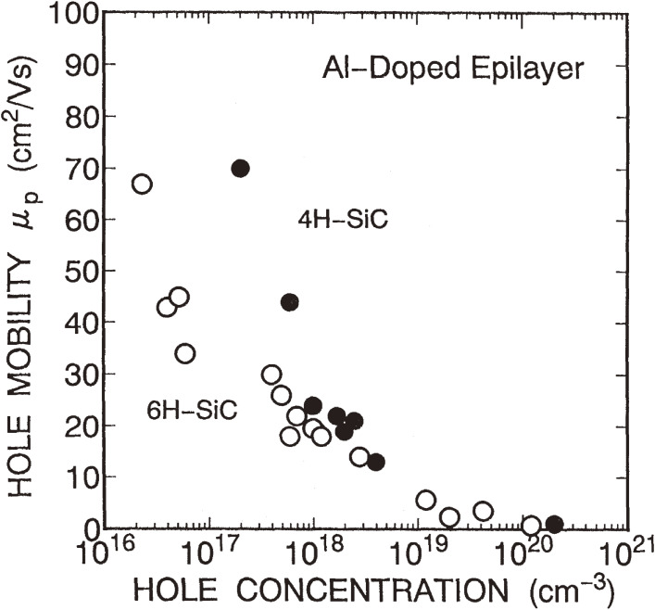
Figure 13.
Hole mobilities vs. hole concentrations at room temperature for Al-doped 6H- and 4H-SiC grown by atmospheric cold-wall CVD. The hole mobilities of 4H-SiC are larger than 6H-SiC for lightly doped layers. The difference becomes small for heavily doped layers.
Boron (B) can be easily doped using B₂H₆ gas as another hopeful acceptor. Although high doping of B did not affect the surface morphology, the growth rate was reduced by 20–30% in epitaxial growth. The B acceptor concentration increases in proportion to the B₂H₆ flow rate. B-doped samples exhibit a high resistivity ascribed to the high ionization energy of B acceptors,^{46,47)} for example, 520 Ωcm in 6H-SiC for a boron concentration of 1 × 10¹⁷ cm⁻³. B-doped layers are known to contain deep levels, so-called D centers, located at 0.6 eV above the valence band, which act as donor-like hole traps.⁴⁷⁾

5.2. Ion implantation.
Ion implantation is very important for selective doping, because diffusion techniques cannot be used for SiC due to the small diffusion constant of impurities.⁴⁸⁾ Hot implantation is effective to recover crystal quality.⁴⁹⁾ In the formation of n⁺-SiC using high-dose nitrogen (N) or phosphorus (P) ion implantation, a low sheet resistance of 290 Ω/□⁵⁰⁾ or 51 Ω/□⁵¹⁾ was reported, respectively. The relatively high resistance of N⁺-implanted layers might be due to the lower solubility of N in SiC (∼10¹⁹ cm⁻³).⁵²⁾ High-dose P⁺ implantation at elevated temperatures and high-temperature annealing above 1,600 ℃ is effective to reduce the sheet resistance, as shown in Fig. ​Fig.1414.^{52–55)} The doping of boron (B) and aluminum (Al) was examined by ion implantation at room temperature and elevated temperatures, and hot-implantation has been suggested to obtain high activation.⁵⁶⁾ In the formation of p⁺-SiC by ion implantation, however, the sheet resistance is still high, in the range of 5–10 kΩ/□, even when using hot implantation, as shown in Fig. ​Fig.1515.⁵⁵⁾

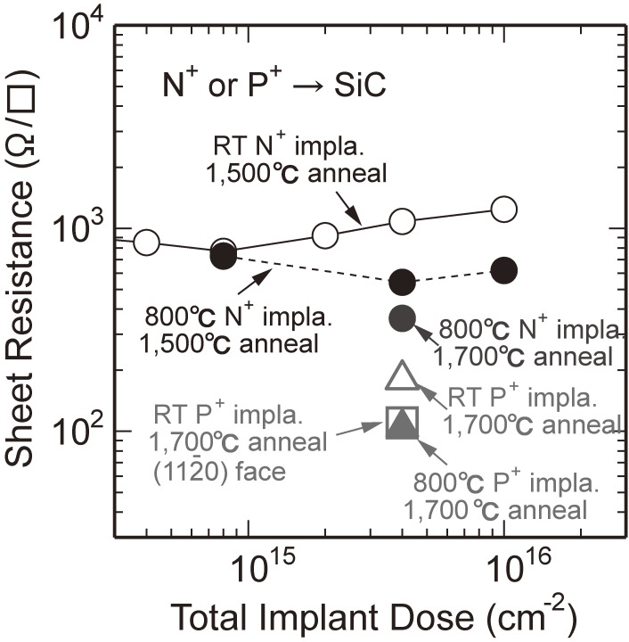
Figure 14.
Sheet resistance vs. total implant dose of N or P for 4H-SiC in hot implantation for n⁺-SiC using high-dose nitrogen (N) or phosphorous (P).

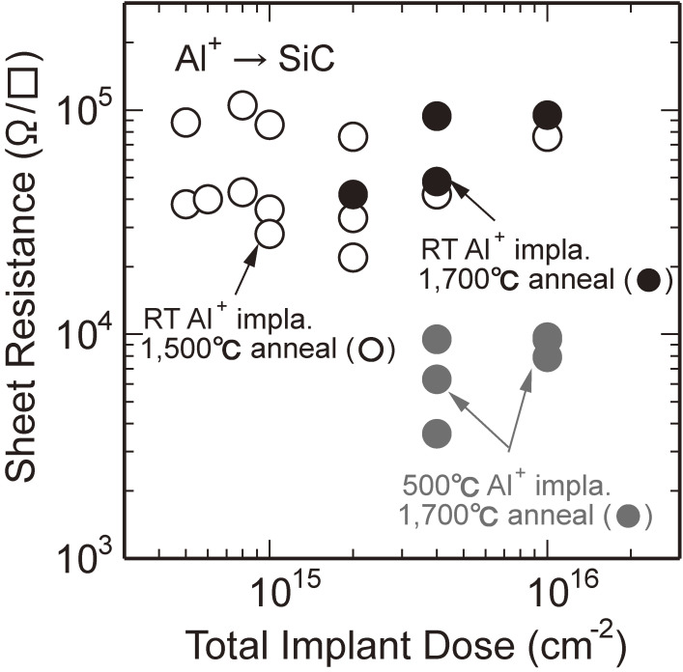
Figure 15.
Sheet resistance vs. total implant dose of Al for 4H-SiC in hot implantation using high-dose aluminum (Al). A high sheet resistances of 5–10 kΩ/□ was obtained.
High-temperature annealing at 1,600–1,700 ℃ is necessary to obtain a higher activation ratio than 90%. However, this causes a roughened surface, which may adversely affect the device performance. Several techniques have been demonstrated to suppress surface roughening: a SiH₄ over pressure, an AlN cap, or rapid thermal annealing. High-dose P⁺ implantation followed by high-temperature annealing succeeded using a graphite cap made by thermal conversion of a spin-coated photoresist at 750 ℃ for 15 min in Ar. Even by annealing at 1,700 ℃, a surface roughness of 1.0 nm was obtained for a dose of 1.0 × 10¹⁶ cm⁻². For a dose of 6.0 × 10¹⁶ cm⁻², the lowest sheet resistance of 45 Ω/□⁵⁷⁾ was obtained. Since high temperature annealing normally generates complexes of point defects, formed by ion implantation, rapid thermal annealing at high temperatures is effective to activate implanted atoms, while not forming defect complexes.

5.3. Ohmic contacts.
Ohmic contacts are very important in device processes, because a voltage drop at the contact under current flow increases the power loss and deteriorates the device performance. Much effort has been made to obtain low-resistivity contacts on SiC.^{58,59)} The most promising material is Ni for n-type and Al-Ti for p-type, and values of 7.0 × 10⁻⁷ Ωcm² for n-type⁶⁰⁾ and 2.8 × 10⁻⁶ Ωcm² for p-type⁶¹⁾ were reported. By optimizing the surface treatment of highly doped (>10¹⁹ cm⁻³) 4H-SiC and post deposition annealing, values of 3.3 × 10⁻⁷ Ωcm² for n-type using Ni and 9.7 × 10⁻⁷ Ωcm² for p-type using Al-Ti were obtained.⁶²⁾ Single-metal Ni showing ohmic properties in the range of 10⁻⁶ Ωcm² and 10⁻³ Ωcm² were reported for ion implanted n- and p-type 4H-SiC.⁶³⁾
Go to:

6. Fundamentals of SiC power devices

6.1. Schottky barrier diodes.
Using CVD growth on commercially available 6H-SiC substrates of 3–4° off-cut, high-voltage 6H-SiC p-n junction diodes with a reverse breakdown voltage of 1,000 V were reported in 1991,⁶⁴⁾ though those diodes were bipolar-type devices. In order to reduce the switching loss, unipolar-type devices have been strongly expected. In 1993, we reported Au-6H-SiC Schottky barrier diodes (SBDs) with a breakdown voltage of over 1,100 V using “step-controlled epitaxially” grown 6H-SiC of Acheson crystals for the first time.^{65,66)} The specific on-resistance of 8.5 × 10⁻³ Ωcm² was the highest value ever reported for SiC SBDs. In 1994, we found that the 4H-SiC epitaxial layers grown on home-made 4H-SiC wafers had much larger electron mobility along the c-axis than that of 6H-SiC, which means a small anisotropy in the electrical conductivity along the c-axis and either the a-axis or the m-axis (60° from a-axis).⁶⁷⁾ Hereafter, 4H-SiC has been used for SBDs and other SiC power devices in the world. In 1995, we reported high-voltage, high-performance Ti-4H-SiC SBDs, as shown in Fig. ​Fig.1616(a).^{68–71)} The epitaxial layer thickness was 13 µm, and the donor concentration was 6 × 10¹⁵ cm⁻³. The device was designed to have a junction termination enhancement (JTE) made by B ion implantation, as shown in Fig. ​Fig.1616(b).^{68–71)} A breakdown voltage of 1,750 V with a specific on-resistance of 5 × 10⁻³ Ωcm² was the world-best during that term.

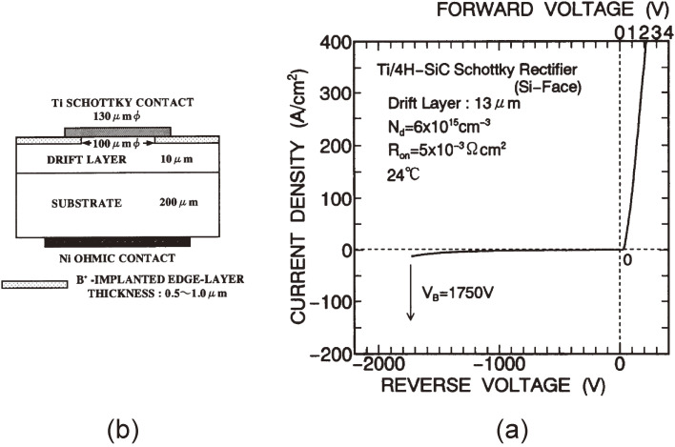
Figure 16.
(a) Current-voltage characteristic for 4H-SiC SBD and (b) junction termination structure fabricated using B implantation.
In order to understand the fundamental physics, the characteristics of the current-voltage (I-V), the capacitance-voltage (C-V), and internal photoemission (IPE) methods were used, to understand the correlation between the work function of metals (Ti, Ni, and Au) and the barrier height of SBDs. As shown in Fig. ​Fig.1717,⁷²⁾ a linear correlation does exist between the Schottky barrier height and the metal work-function, for both Si- and C-faces. This relation means no surface Fermi level pinning, as in Si and GaAs. The slopes of the linear line for Si- and C-faces were 0.70 and 0.76, though the ideal slope should be unity.

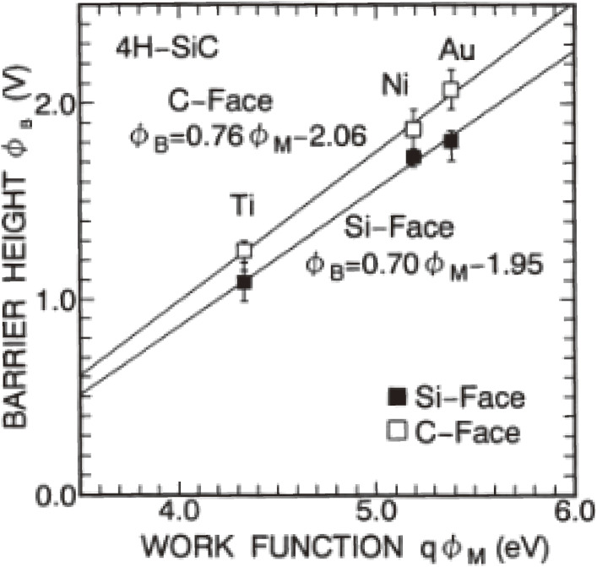
Figure 17.
Relation between the barrier heights and different metal work functions in 4H-SiC SBD. The metals are Ti, Ni, and Au.

6.2. MOS (metal-oxide-semiconductor) interface and MOSFETs.
For SiC MOSFETs, the SiO₂/SiC interface is most important. Although 4H-SiC had been regarded as being the most promising polytype owing to its higher bulk mobility and smaller anisotropy than 6H-SiC, inversion-type MOSFETs on off-axis 4H-SiC(0001) generally showed unacceptably low channel mobility, typically below 10 cm²/Vs.^{73,74)} A major obstacle to form a high-quality oxide on SiC is due to the role of carbon during oxide growth. Thermal oxidation in wet or dry atmospheres resulted in residual carbon in the oxide layer and carbon clusters at the SiO₂/SiC interface. In as-oxidized SiO₂/SiC, the interface state density is dominated by carbon-cluster related centers responsible for donor states in the lower part of the SiC band gap and for continuous states in the central part of the SiC band gap. Acceptor-type defects in the upper part of the SiC band gap are likely to be related to intrinsic oxide defects correlated with an O-deficiency.^{75,76)} The characteristics of the SiO₂/SiC interface were substantially improved by using either re-oxidation annealing⁷⁷⁾ or a H₂ treatment.⁷⁸⁾ Oxidation or post-oxidation annealing in a nitrogen-containing atmosphere was found to be the most effective method to enhance carbon removal and to incorporate nitrogen at the interface, thereby lowering the interface trap densities and improving the dielectric strength and reliability.⁷⁹⁾ The most effective gas for achieving this effect is nitric oxide (NO) or nitrous oxide (N₂O).
We reported a remarkably improved channel mobility by using wet oxidation for SiC (112¯0) instead of conventional (0001), and obtained either 95.9 cm²/Vs along 〈0001〉 or 81.7 cm²/Vs along 〈11¯00〉, above 16-times larger, as shown in Fig. ​Fig.1818.⁸⁰⁾ Low-field channel mobilities for (112¯0) have the T^{−2.2} dependence, as shown in Fig. ​Fig.1919,⁸⁰⁾ which indicates the contribution of phonon scattering instead of decreased Coulombic scattering and/or the de-trapping of electrons.⁸¹⁾ However, for (0001) they have a T^{2.6} temperature dependence, indicating Coulombic scattering. This is a big step for the progress of SiC-MOSFET’s technologies. These results indicate the lower interface state density near to the band edge on (112¯0) than on (0001). Based on this result, the author strongly recommends for Japanese companies to try “trench MOSFETs”. The structural difference of planer and trench MOSFETS is shown in Fig. ​Fig.20.20. Normally, trench MOSFETs are used to increase the drain current so as to utilize many small transistors in parallel along the vertical direction. However, in the case of SiC, the channel electron mobilities on (112¯0) are much larger than on (0001) by utilizing the above effects.

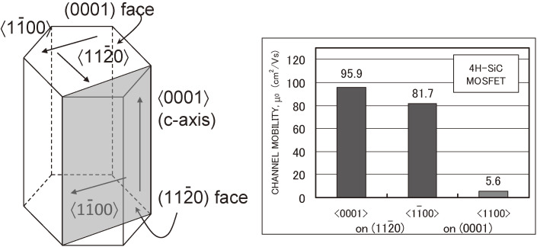
Figure 18.
Comparison of the channel mobilities for the (112¯0) and (0001) planes of 4H-SiC. The channel mobilities on (112¯0) are 95.9 cm²/Vs along 〈0001〉 or 81.7 cm²/Vs along 〈11¯00〉, above 16-times larger than on (0001).

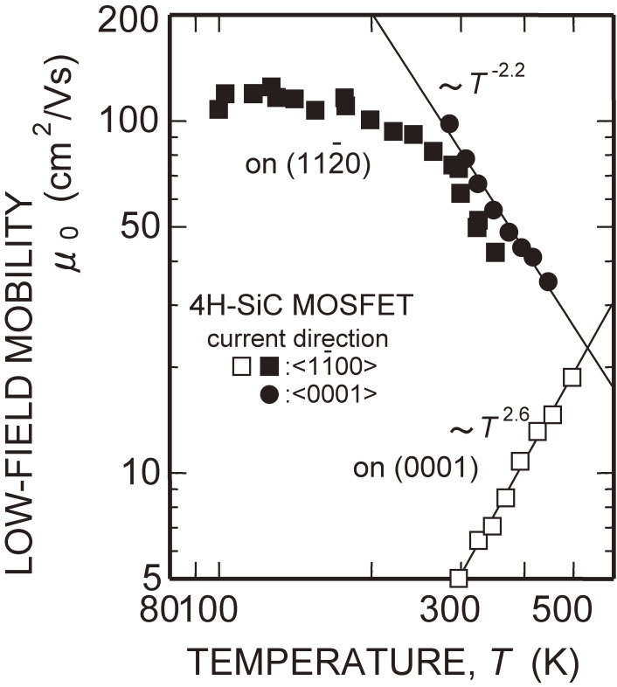
Figure 19.
Temperature dependence of the low-field channel mobility: for (112¯0) has the T^{−2.2} dependence showing phonon scattering, whereas that for (0001) has the T^{2.6} dependence, indicating Coulombic scattering.

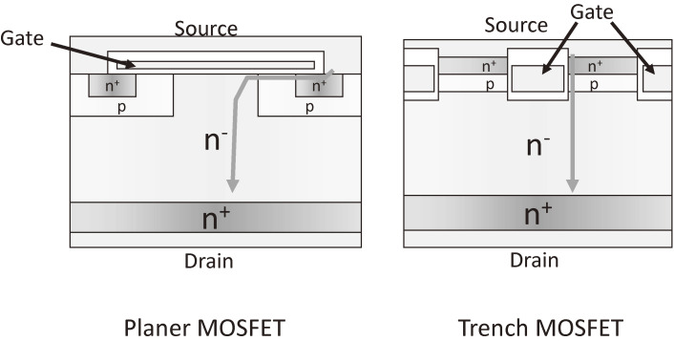
Figure 20.
Difference of planer MOSFET and trench MOSFET.
To investigate the SiO₂/SiC interface properties on various crystal orientations, MOS capacitors on N-doped n-type epitaxial layers of 4H-SiC off-axis (0001), (112¯0), and (033¯8) were characterized.⁸²⁾ In Fig. ​Fig.21,21, the relation between the hexagonal structure and the cubic structure is shown. The interface state densities, calculated from the conductance method for (0001), (112¯0), and (033¯8), are shown in Fig. ​Fig.2222,⁸²⁾ in which the energy position is plotted from the valence band edge; (0001) shows a quite high interface state density near the conduction band edge, though it has a low interface state density at deeper energies; (112¯0) and (033¯8) have the lower interface state density near the conduction band edge than on (0001). The different profiles for various crystal orientations may come from different origins and numbers of interface states, which should be clarified.

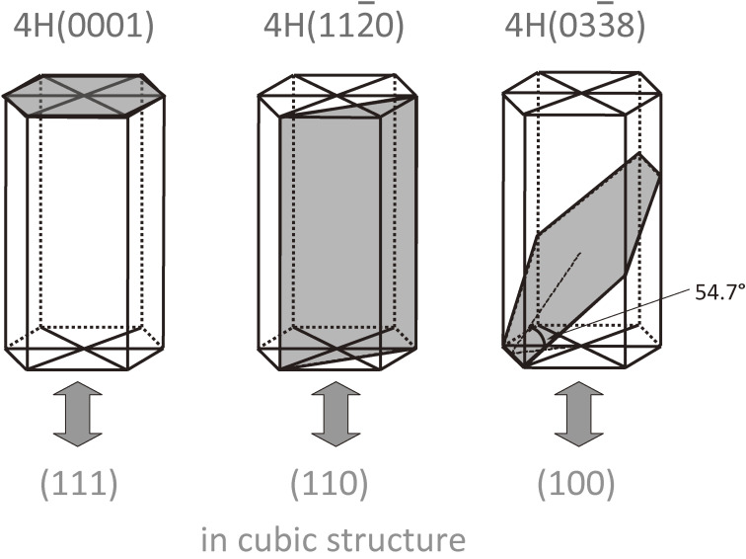
Figure 21.
Relation between 4H-SiC (0001), (112¯0) and (033¯8) and corresponding cubic structures.

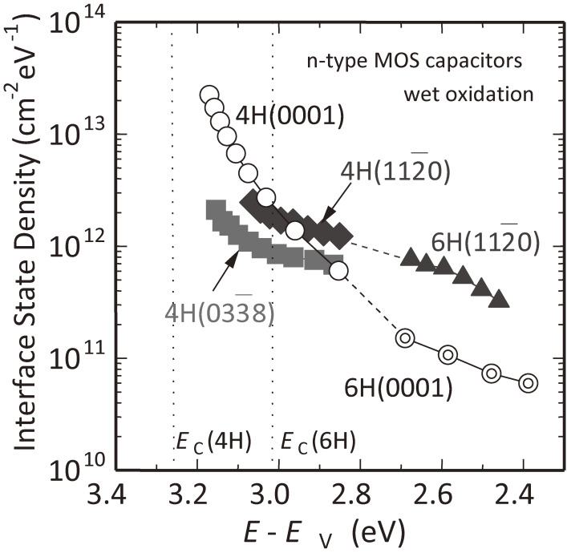
Figure 22.
Interface state density calculated from a conductance method for 4H-SiC (0001), (112¯0) and (033¯8). (112¯0) and (033¯8) have the lower interface state density near the conduction band edge than on (0001).
Comparisons of the drain current characteristics obtained are shown in Fig. ​Fig.2323.⁸²⁾ In this figure, the drain current, I_{D}, was normalized by the oxide capacitance, C_{ox}, channel length, and channel width to get rid of the oxide thickness. The higher drain current and steeper slope for (033¯8) suggests a higher channel mobility for this orientation. The lower threshold voltage for (033¯8) than for (112¯0) and (0001) indicates a smaller number of trapped electrons at the MOS interface. As an alternative to using non-standard crystal orientations, a possibility to obtain a high channel mobility on 4H-SiC (0001¯)-C faces was demonstrated.⁸³⁾

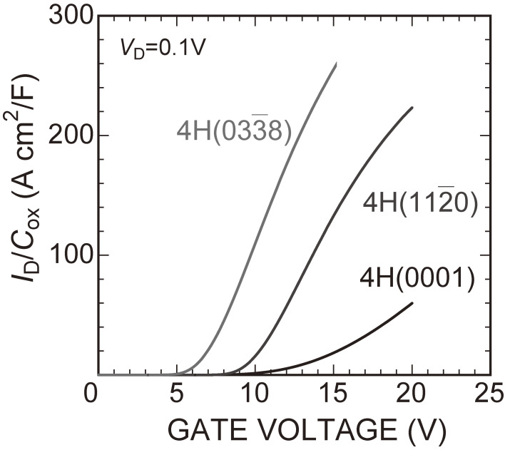
Figure 23.
Normalized drain current vs. gate voltage characteristics of MOSFETs on 4H-SiC (0001), (112¯0) and (033¯8). The drain current, I_{D}, is normalized by the oxide capacitance, C_{ox}, channel length, and channel width to eliminate the effect of the difference in the oxide thickness. The higher drain current and steeper slope for (033¯8) suggest a higher channel mobility than for either (112¯0) or (0001).
Although many arguments concerning small effective channel mobility have been reported, the values were calculated from the drain current of MOSFETs using the assumption that all of the electrons induced in the channel move upon the application of a gate voltage. A detailed analysis of Hall measurements for the MOS inversion channel gave the following basic result: the actual inversion Hall mobility can be higher by a factor of ten than the effective mobility in some SiC devices.⁸⁴⁾ Also, electron trapping at shallow acceptor-like interface states leads to reduce the number of mobile inversion electrons in the case of the 4H-SiC (0001) face.
Go to:

7. Development of 4H-SiC high-power devices
The high performance of high-voltage 4H-SiC SBDs was demonstrated in 1995^{68,69)} followed by details of the efficient power 4H-SiC SBDs. Excellent reverse blocking characteristics of high-voltage 4H-SiC SBDs with boron-implanted edge termination⁷¹⁾ were very effective. Efforts had been made to develop SBDs with a breakdown voltage of several kilovolts and one-hundred amperes. Subsequently, 4H-SiC p-n junction diodes either by epitaxial growth or ion implantation were extensively developed.
To solve the low channel mobility of MOSFETs, accumulation FETs (ACCUFETs),⁸⁵⁾ epi-channel FETs (EC-FETs),⁸⁶⁾ and static induction injected accumulated FETs (SIAFETs)⁸⁷⁾ were proposed. Several switching devices using junction FETs (JFETs) and static expansion channel JFETs (SEJFETs)⁸⁸⁾ had been developed. Although the above-mentioned various trials to develop SiC power devices were done, the device structures were rather complicated, which blocked their progress. The trend for the development of 4H-SiC power devices was directed to normally-off unipolar devices: “DMOSFETs” or “trench MOSFETs”.
Commercially available 4H-SiC SBDs were announced in 2001 by a German company (SiCED, now in Infineon). Subsequently, an announcement of mass production was made in April 2010 by a Japanese company (ROHM; https://www.rohm.com/news-detail?news-title=low-drive-voltage-high-efficiency-sic-schottky-barrier-diodes&defaultGroupId=false). This company announced the world-first mass production of 4H-SiC DMOSFETs in December 2010 (https://www.rohm.com/news-detail?news-title=the-world-s-first-low-on-resistance-high-speed-sic-transistor-dmosfet-&defaultGroupId=false). The company then reported 4H-SiC “trench MOSFETs” in 2011 at IEDM.⁸⁹⁾ The world-first mass production of 4H-SiC trench MOSFETs was announced in April 2015 by the same company (https://www.rohm.com/news-detail?news-title=2015-04-23_ad_mos&defaultGroupId=false).
Go to:

8. Progress of SiC power devices and social implementation in Japan
In 1993 we presented our work on Au-6H-SiC SBDs⁶⁵⁾ at ICSCRM (International Conference on SiC and Related Materials) held in Washington DC. After this presentation, a researcher from a German company praised the author for the high performance of the SBDs. He said that the power electronics material for post Si-IGBTs should be SiC and had already started fundamental research from one year before. A U.S.A. venture company handling SiC wafers started in 1987. The author felt strong fear to face the difficult situation that SiC wafers are held by U.S.A. and devices by Germany, and then Japan should be forced to conduct only assembly and may not play a leading role in future activity. The author thought that national projects should be planned in order to expand those activities in Japan and contributed to startup activity.
Subsequently, more than eight projects on SiC power devices have been executed through support of the Japanese government. Among them, two big projects started after the Lehman shock, one for SiC-IGBTs for ultra-high voltage, and the other concerning high-voltage SiC power devices (SBDs, MOSFETs). The latter stimulated large companies in Japan to join the effort. Four to five large companies manufactured many SiC power devices, and those devices have been used in Japan to demonstrate implementation within society.
After SiC-SBDs were commercialized in 2001, they have been practically used for almost 20 years. They have a much higher performance level than Si-pin diodes and are widely used. In 2010, air-conditioners with Si-IGBTs and SiC-SBDs (hybrid inverter system) (http://www.mitsubishielectric.co.jp/news-data/2010/pdf/0824-d.pdf) were commercialized. In 2012, hybrid systems were installed in metro trains (DC 600 V) in Tokyo (https://www.mitsubishielectric.com/news/2013/pdf/0326-a.pdf), which showed a 38.6% electric power loss reduction. Then, full SiC inverter systems (SiC-SBDs and SiC-MOSFETs) were installed in suburban trains (DC 1,500 V) (https://www.mitsubishielectric.com/news/2014/pdf/0430.pdf) with a 40% electric power loss reduction in 2014. Their application to elevators (http://www.mitsubishielectric.co.jp/news/2013/0226.html) was tried in 2013, which showed a 65% electric power loss reduction together with a 40% reduction in the installation area and volume. Then, their application to hybrid electric vehicles (https://global.toyota/en/detail/2656842/) was demonstrated in 2014, which gave a 5% reduction in the fuel economy. Commercial fuel-cell vehicle applications (https://automobiles.honda.com/clarity-fuel-cell) started in 2016, where fuel cells, SiC DC-DC converters and traction systems were stored under a bonnet, which allows sufficient space in a sedan-type car. In addition, power control systems for photovoltaics (https://www.omron.co.jp/press/2014/02/c0207.html) were announced in 2014. The masterpiece is the installation of SiC inverters and converters in bullet trains (Shinkansen: JR Central) (https://www.mitsubishielectric.com/news/2015/pdf/0625.pdf, https://www.fujielectric.com/company/news/2015/20150625120019879.html, https://www.toshiba.co.jp/sis/topics/2015/20150625.htm, https://www.hitachi.co.jp/New/cnews/month/2015/06/0625a.html). Owing to the high performance of SiC power devices, transformers could be made compact, and in the motor winding system a change was made from 4 to 6 poles, and the traction system became highly efficient. Eventually, a weight reduction by 11 tons for 1 train with 16 cars was announced. These trains will run every day from the summer of 2020.
As new applications, various ideas started to be realized: (i) motors with mechanical and electrical integration using SiC inverters, (ii) sensors and power supplies in robots for the decommissioning of nuclear reactors, (iii) high-power apparatuses for power infrastructures and (iv) high-power supplies for medical equipment applications. In power systems, nowadays, a huge number of power converters, mainly Si-IGBTs, are used. When SiC power devices replace Si-IGBTs, low-loss and compact systems will be realized, which will contribute to energy saving, and eventually help to reduce global warming and environmental impacts. Trials to replace systems of Si-IGBTs and Si-pin diodes by those of SiC-MOSFETs and SiC-SBDs will be implemented in society. In addition, applications of SiC power devices have started for flying cars, drones, aircrafts, and ships.
Compact BNCT (Boron Neutron Capture Therapy) equipment is now being developed in a Japanese venture company (http://en.fukushima-sic.co.jp/technology.html). The generation principle of a neutron beam is quite new and has an advantage of compactness using a SiC electric power supply. A prototype was fabricated, and animal experimentation is now planned. When this system is practically used, a big breakthrough will happen in cancer treatment. Since this attempt is taking place nowhere else in the world, there is no doubt about the superiority.
Go to:

9. Summary and future prospects
Technological breakthroughs in the epitaxial growth of SiC were reviewed based on fundamental research conducted by the author’s group. The details of “step-controlled epitaxy” of SiC on off-axis {0001} substrates were examined in detail. The introduction of the substrate off-angle concept allowed ‘step-flow growth’, which is essential to realize polytype replication in growth without polytype mixing. High-quality homoepitaxial layers were obtained by CVD at 1,500 ℃. The off-angle dependence, rate determining processes, and temperature dependence of the growth rate were demonstrated. Optical and electrical characterizations of undoped epitaxial layers were shown. Details of impurity doping during growth and ion implantation were explained. Finally, applications of SiC high-power devices in Japan were briefly described.
The development of SiC power devices, which started from the author’s strong intention, has become successful. Regarding performance, SiC power devices greatly surpass Si power devices. In Japan, large amounts of SiC power devices have been produced in big companies partly supported by national projects. In society implementation, Japan is greatly ahead of other countries.
Go to:

Acknowledgements
The author gives thanks to the editorial board of Proceedings of the Japan Academy, Ser. B for providing an opportunity to review the history of the author’s group activities as well as the present-day trends of semiconductor SiC power devices. He is greatly indebted to Professor T. Kimoto of Kyoto University. He sincerely thanks Dr. S. Nishino, late Dr. A. Itoh, late Dr. K. Shibahara, and Dr. H. Yano. The author also greatly appreciates the staff members, graduate students, and senior students in his laboratory at Kyoto University. He further thanks Prof. T. Nakamura of Osaka University. The author has been mainly supported by the MEXT (Ministry of Education, Culture, Sports, Science and Technology) through “Grants-in-aid for Scientific Research”

